Spectrum Analysis and Amplitude Modulation

Louis Zeng

Fitzwilliam College, Lab Group 73

**Introduction**

This experiment involves examine signals’ spectra in the frequency domain by using a spectrum analyser (the waveforms are transformed from the time domain), and confirming the spectral view of the AM (amplitude modulated) signal on the picoscope results agree with the equation given. The experiment also involves altering the ‘carrier’ signal amplitude and calculating the corresponding modulation index. Also due to the modulated signal contains 3 different frequencies (one at the carrier frequency and two side bands), a demodulator was also tested at different test points to explore its inner circuitry.

**Reading and Results**

Figure 1. Spectrum and waveform of 2kHz sine wave from the simple signal source (Q5.1)

Figure 2. Spectrum and waveform of 1kHz 2V p-p square wave with low-pass filter (Q5.4)

Figure 3. Spectrum and waveform of 1kHz 2V p-p square wave with low-pass/anti-aliasing filter (Q5.4)

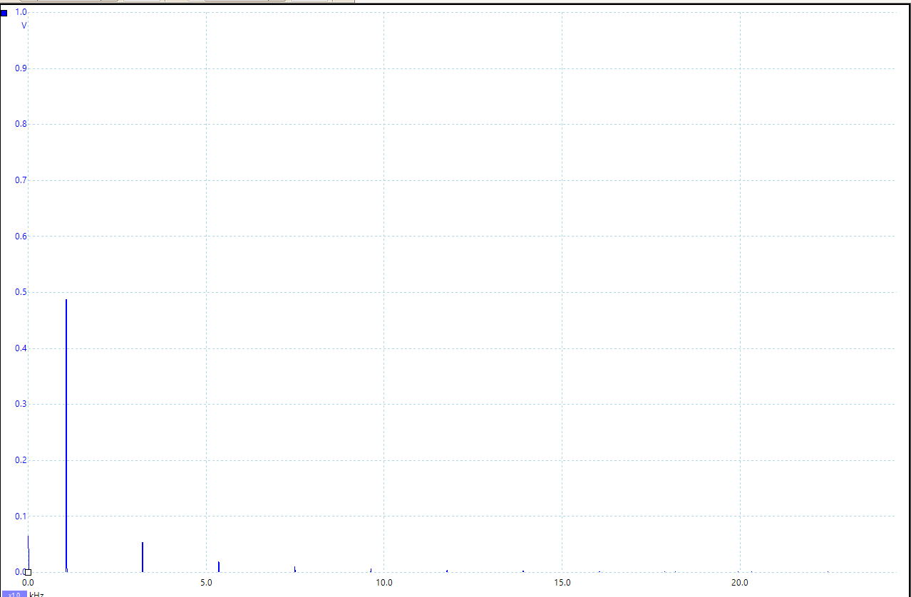

Fig 3. Spectrum and waveform of 1kHz 2Vpp triangle wave(Q5.5)

Up right spectrum with low-pass filter, lower spectrum without low-pass filter.

By inspection of the spectrum, it is clear to see that the magnitude terms by a factor of 1/n^2.

Figure 4. Spectrum and signal waveform of 8kHz carrier signal modulated with 1kHz sine signal source. (Q6.2)

Modulation index m = 0.508 (Q6.3)

Figure 5. Spectrum and waveform of 8kHz carrier signal modulated with 1kHz sine signal source, m = 1 (Q6.5)

N.B. When the modulation index is set to its maximum value of m=1, there were overlappinbg between different frequencies.

Figure 6. Spectrum and waveform of 8kHz carrier wave modulated with 1kHz sine information signal, with carrier frequency component supressed on the spectrum, m=0.848 (m value is debatable, since Ec = 0) (Q6.6)

Fig 7. Clean 1kHz sine wave from the demodulator output

**Conclusions**

1. Spectral view of the are wave functions in frequency domains are expected as a Fourier transform being applied on the signal wave, decaying like 1/n or 1/n^2.

2. Amplitude modulation and the frequency components make up a modulated signal of a pure sine wave.

3. Demodulator can be tested at different test points in order to deduce its inner circuitries.